Inverters

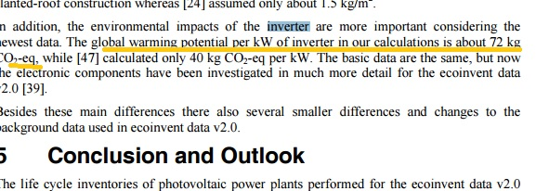

Taken into account:

energy consumption,

• air- and waterborne process-specific pollutants at all production stages,

• materials, auxiliary chemicals, etc.

• transport of materials, of energy carriers, of semi-finished products and of the complete power plant,

• waste treatment processes for production wastes,

• dismantling of all components,

• infrastructure for all production facilities with its land use

\*the underlined number is more recent compared to the number that comes right after

Source:

http://www.esu-services.ch/fileadmin/download/jungbluth-2008-LCA-PV-web.pdf